Call for Global Support: Urgent Appeal for the Restoration of Nepal's Public Assets
Date: September 24, 2025
Issued by: Government of Nepal, Ministry of Urban Development, Physical Infrastructure Reconstruction Fund Development Committee

A Nation in Transition: The Aftermath of the Gen-Z Movement
Nepal, a resilient Himalayan nation known for its enduring spirit and cultural richness, stands at a pivotal crossroads. The recent Gen-Z movement, while a powerful expression of youth aspirations for justice and reform, has left an indelible mark on our collective landscape. Tragically, the unrest resulted in heavy casualties and widespread embezzlement of public property, with hundreds of vital public buildings, administrative offices, and community centers—and public vehicles essential for public services vandalized or destroyed. This devastation has not only disrupted daily life but also strained the fabric of our society, hindering the public access to basic services and governance.
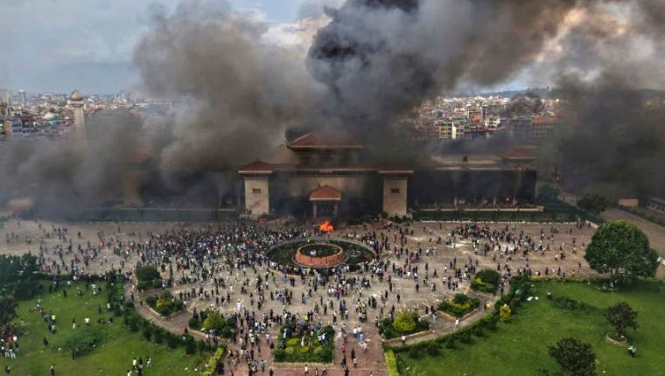
In the wake of this turmoil, the Government of Nepal is committed to a swift and transparent transition toward stability and renewal. Recognizing the immense challenges ahead, the Government of Nepal has established a dedicated Physical Infrastructure Reconstruction Fund to spearhead the restoration efforts. This initiative is a beacon of hope, transforming loss into opportunity for rebuilding stronger, more inclusive public infrastructure that serves all Nepalis.
We extend our deepest gratitude to the global community for standing with us during these trying times. Your solidarity has been our strength, and now, we humbly call upon you once more.

Objective of the Reconstruction Fund
The primary objective of the Reconstruction Fund is to systematically restore and rehabilitate the vandalized public properties, ensuring Nepal's public assets are revived to their full functionality within the shortest possible timeframe.
This fund will prioritize:
- Immediate Assessment and Maintenance & Repair: Conducting rapid structural assessments of affected public buildings to identify urgent repair and maintenance needs of the public buildings and prompt actions.
- Sustainable Reconstruction: Employing eco-friendly materials and modern engineering standards to build resilient structures that withstand future challenges.
- Community Empowerment: Involving local communities, including youth from the Gen-Z generation, in the reconstruction process to foster ownership and promote social cohesion.
- Equitable Access: Ensuring restored facilities prioritize underserved regions, such as rural districts and earthquake-prone areas, to bridge urban-rural divides.
By achieving these goals, the fund will not only repair physical damage but also heal societal wounds, reinforcing Nepal's democratic values and commitment to good governance. The reconstruction will symbolize our nation's unbreakable resolve to rise from adversity, creating safer, more accessible public spaces for generations to come.
This initiative aligns with Nepal's National Reconstruction Policy, emphasizing transparency, accountability, and international best practices. All funds will be managed through audited channels, with quarterly progress reports shared publicly via the official government portal.

Urgent Funding Needs and Timeline
To kickstart this vital campaign, the Government of Nepal requires Billions of Rupees to be raised within a short intensive period of 90 days (October 1, 2025 – December 31, 2025). These funds will enable reconstruction, covering most of critical sites and restoring essential services by early 2026. Every contribution, no matter the size, will directly impact lives—rebuilding a public asset means educating people to contribute in nation building and future leaders.

Who We Are Calling Upon
This appeal is directed to our global family:
- Nepalese Diaspora Abroad: Your remittances have long sustained us; now, invest in our shared homeland.
- Foreign Friends and International Partners: Nations and organizations worldwide—your expertise and generosity have guided Nepal through past crises.
- Well-Wishers Everywhere: Individuals moved by Nepal's story of perseverance and beauty.
- Nepalese Citizens at Home: Your domestic contributions will ignite national pride and unity.
- Nepalese Well-Wishers Worldwide: From every corner of the globe, your support echoes our collective heartbeat.

How to Contribute

Donations are secure, tax-deductible where applicable, and processed through the official:
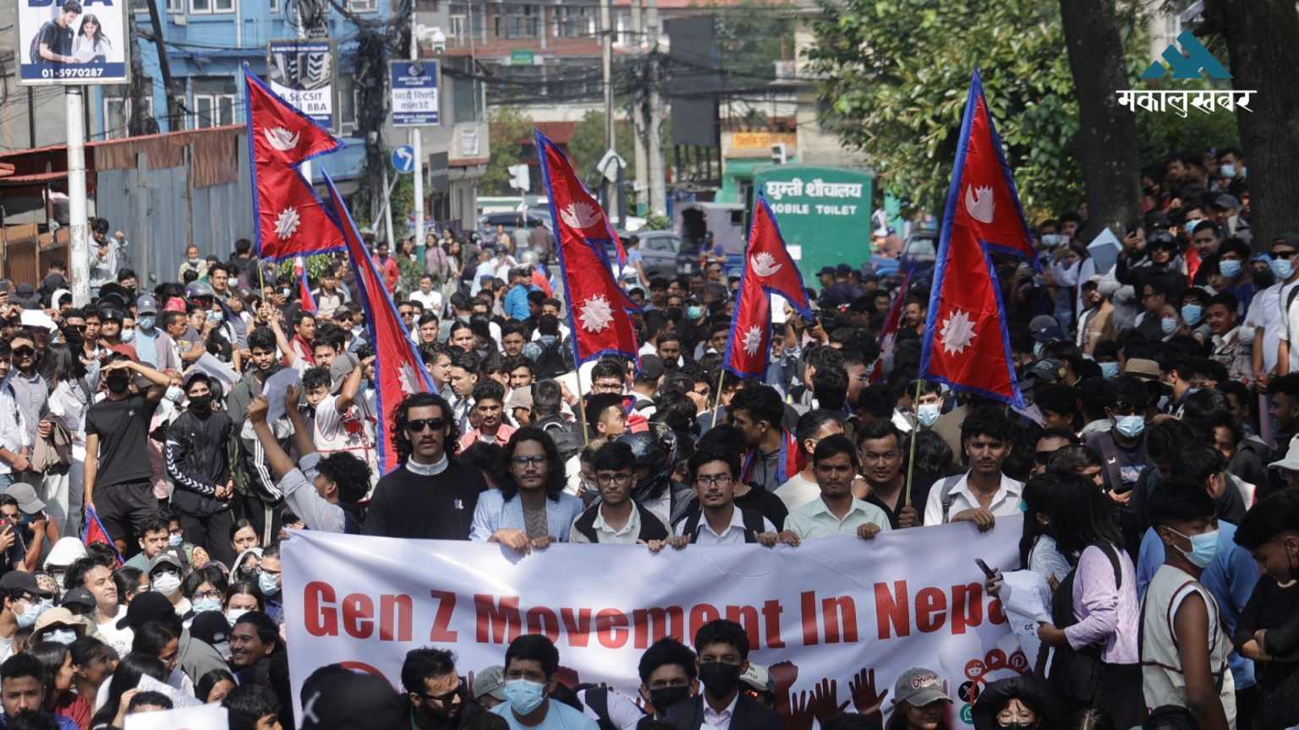

- Fund: Physical Infrastructure Reconstruction Fund
- Bank: Rastriya Banijya Bank (RBB)
- Account Number: 1960100102070004
- Swift Code: RBBANPKA
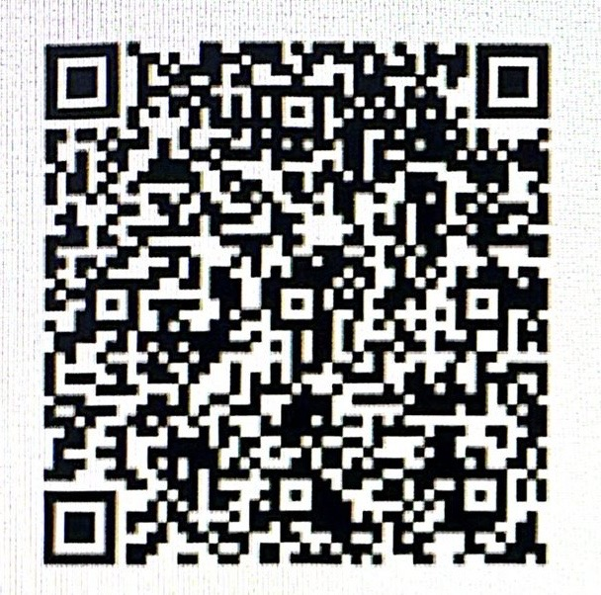

Online Donation Portal: Visit our website for seamless contributions via credit card, PayPal, or mobile wallet. For corporate pledges or matching grants, contact info@moud.gov.np.

A Call to Action: Be the Change Nepal Needs
Time is of the essence. The 90-day window is our window to rebuild trust, restore hope, and reclaim our future. Join us in this noble endeavor—your donation today will echo through Nepal's valleys for years to come. Together, let us turn the page on destruction and script a chapter of renewal.
For inquiries: info@moud.gov.np | +977-1-421-1261

